Agenda

Time | Activity | Location
7:00 – 7:10 | Welcome and Special Acknowledgements  Ms. Christine Nobbe | Multi-Purpose Room
7:15 – 7:50 | Blast Off!  Ms. Jennie Bellinger  Challenger Learning Center | Multi-Purpose Room
7:50 – 7:55 | Travel Time
7:55 – 8:20 | Session One Activities | Throughout the building
8:20 – 8:25 | Travel Time
8:25 – 8:50 | Session Two Activities | Throughout the building
8:50 – 9:00 | Visit a speaker and ask a question, view Moon through telescope, see lunar rocks, have a piece of cake
9:00 | End of evening

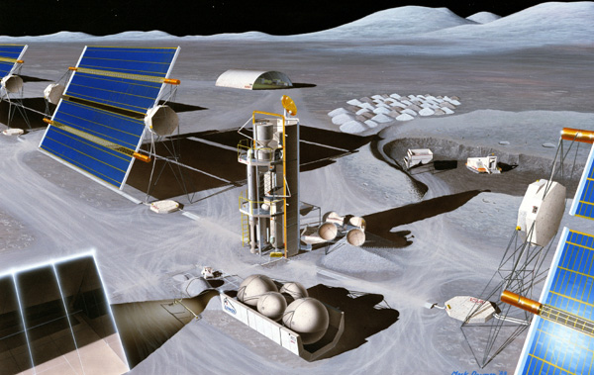

Please plan your evening.
You will be able to attend
two sessions.
The options for those sessions are on the next pages.

Session One

7:55 – 8:20

Choose one of the following for session one:
✓ | Topic | Presenter | Room
 | Mercury & Gemini Spacecraft | Mr. Ray Tucker  Retired, McDonnell Douglass | 11
 | Exploration of Near Space | Dr. Paul Czysz  St. Louis University – Parks College | 10
 | Welding in Space: The Vomit Comet Experience OR  Missouri Rolla Satellite: Mr. SAT | UMR Students  Dave Harris, Julia Hopfer, Andrea Kive, Michelle Rader,  Hannah Longworth-Mills, Carl Seubert, Christopher Solomon, Jacob Zeiger | 12
 | Galileo Mission to Jupiter | Dr. Jerry Cline  Retired, McDonnell Douglas | 14
 | Oh, What to do with Space Station Poo! | Mr. Dave Heck  Boeing | 16
 | The Mar’s Rovers Update and Lunar Exploration | Dr. Brad Joliff  Washington University | 18
 | Moon Madness Collage of Experiences  Moon Rocks  Telescopes to View Moon  Gravity Bricks  Student Projects  MovieMaker Premier | Ms. Christine Nobbe  NASA Educational Workshop (NEW) Teacher  St. Louis Astronomical Society  St. Louis Moon Society  CCL Students | Moon Rocks – Find Ms. Nobbe; Telescopes on Playground;  MovieMaker – Room 2; Bricks & Projects –Hallways

Session Two

8:25 – 8:50

Choose one of the following for session two:
✓ | Topic | Presenter | Room
 | Mercury & Gemini Spacecraft | Mr. Ray Tucker  Retired, McDonnell Douglass | 11
 | Exploration of Near Space | Dr. Paul Czysz  St. Louis University – Parks College | 10
 | Welding in Space: The Vomit Comet Experience OR  Missouri Rolla Satellite: Mr. SAT | UMR Students  Dave Harris, Julia Hopfer, Andrea Kive, Michelle Rader,  Hannah Longworth-Mills, Carl Seubert, Christopher Solomon, Jacob Zeiger | 12
 | Galileo Mission to Jupiter | Dr. Jerry Cline  Retired, McDonnell Douglas | 14
 | Oh, What to do with Space Station Poo! | Mr. Dave Heck  Boeing | 16
 | The Mar’s Rovers Update and Lunar Exploration | Dr. Brad Joliff  Washington University | 18
 | Moon Madness Collage of Experiences  Moon Rocks  Telescopes to View Moon  Gravity Bricks  Student Projects  MovieMaker Premier | Ms. Chris Nobbe  NASA Educational Workshop (NEW) Teacher  St. Louis Astronomical Society  St. Louis Moon Society  CCL Students | Moon Rocks – Find Ms. Nobbe; Telescopes on Playground;  MovieMaker – MPR; Bricks & Projects –Hallway

